What does unsecured mean in an anesthesia station?
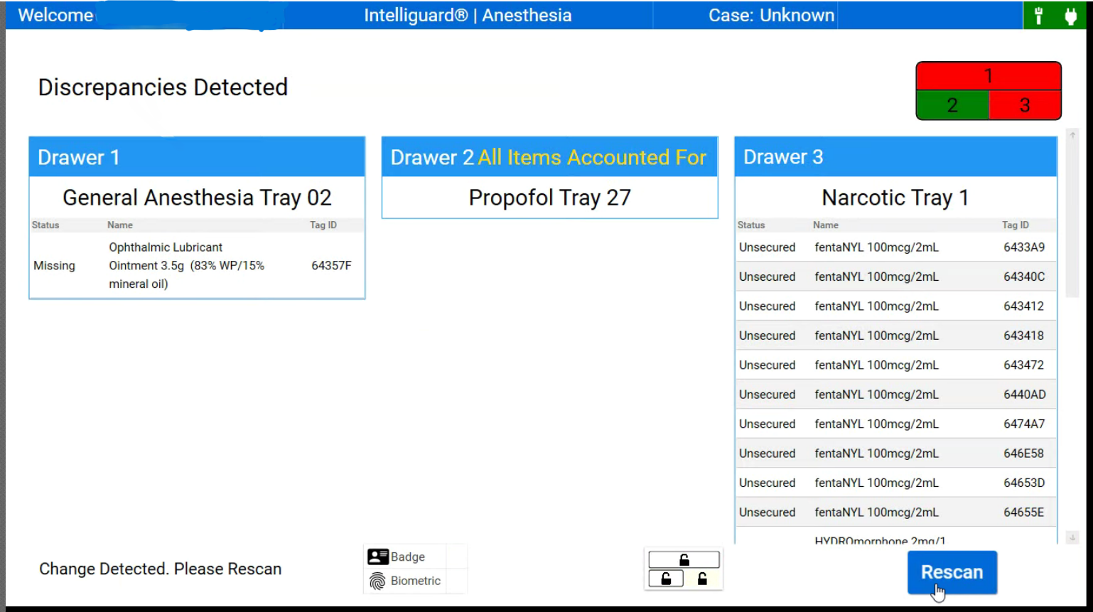
- If there is a tray that is appearing with the status as unsecured next to the medications, this means that the tray was not approved in the pharmacy.

