RFID INTELLIGUARD Remote Access

- Ask customer/Pharmacy to place request with IT Help Desk to activate Intelliguard account.
- Go to this site: gateway.islandhealth.ca
- Account: Intelliguard
- Password: nfHwP876
- Instructions: use RDP client icon within Citrix Receiver

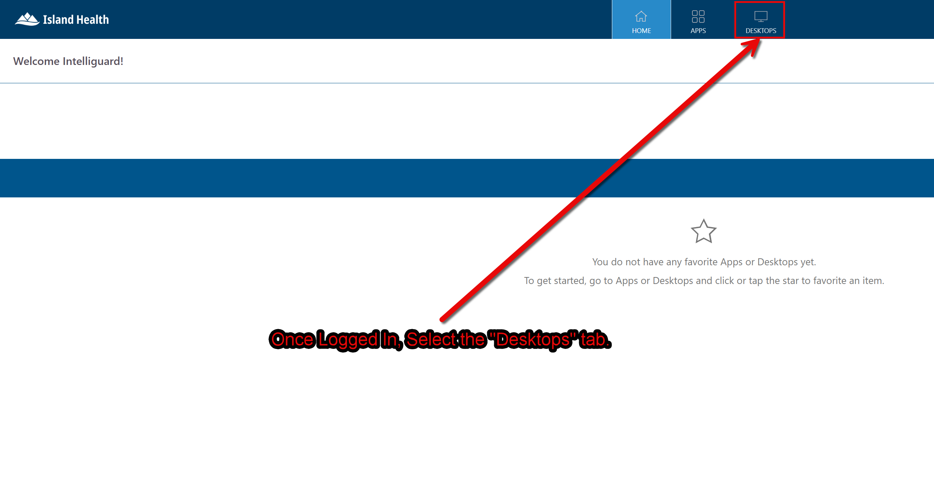

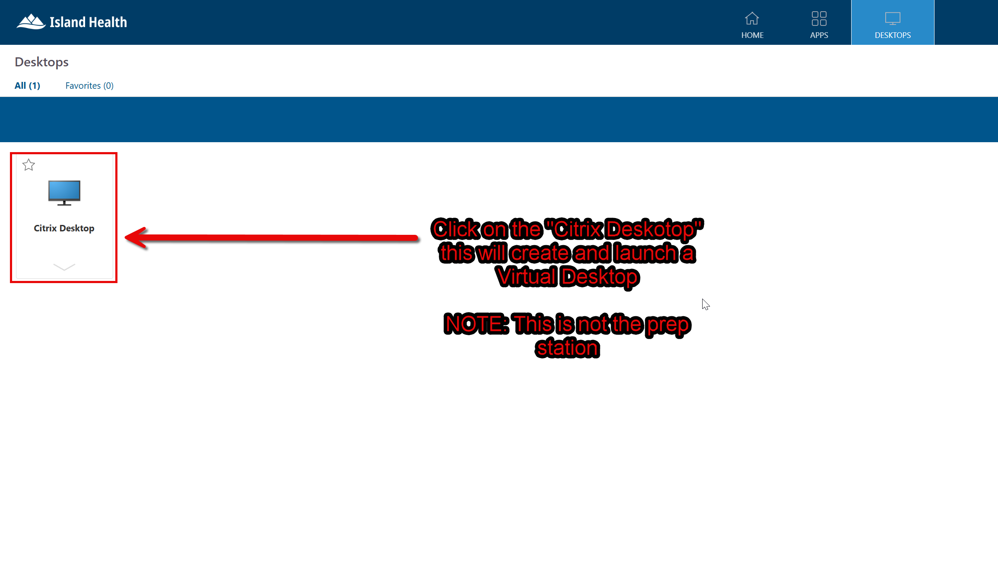

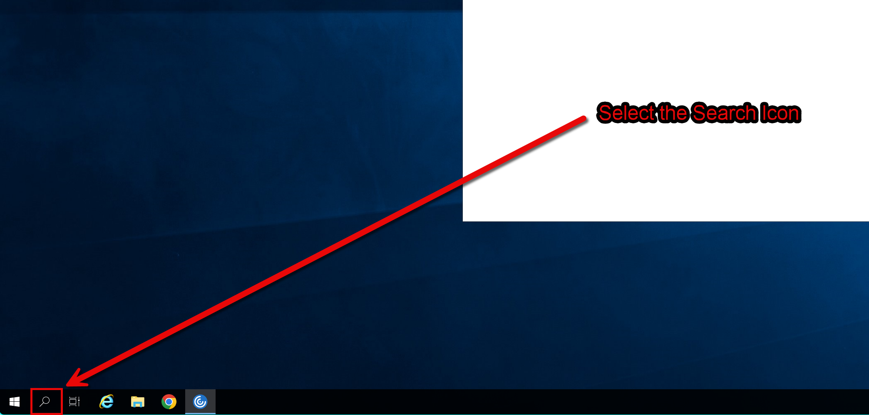
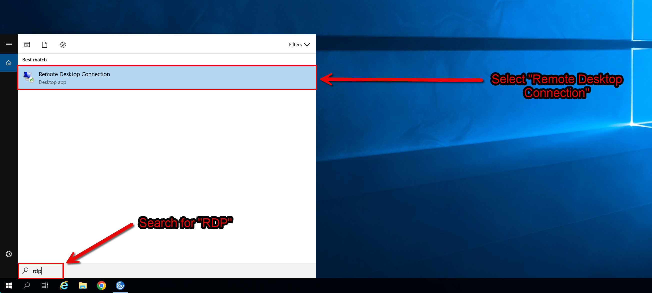
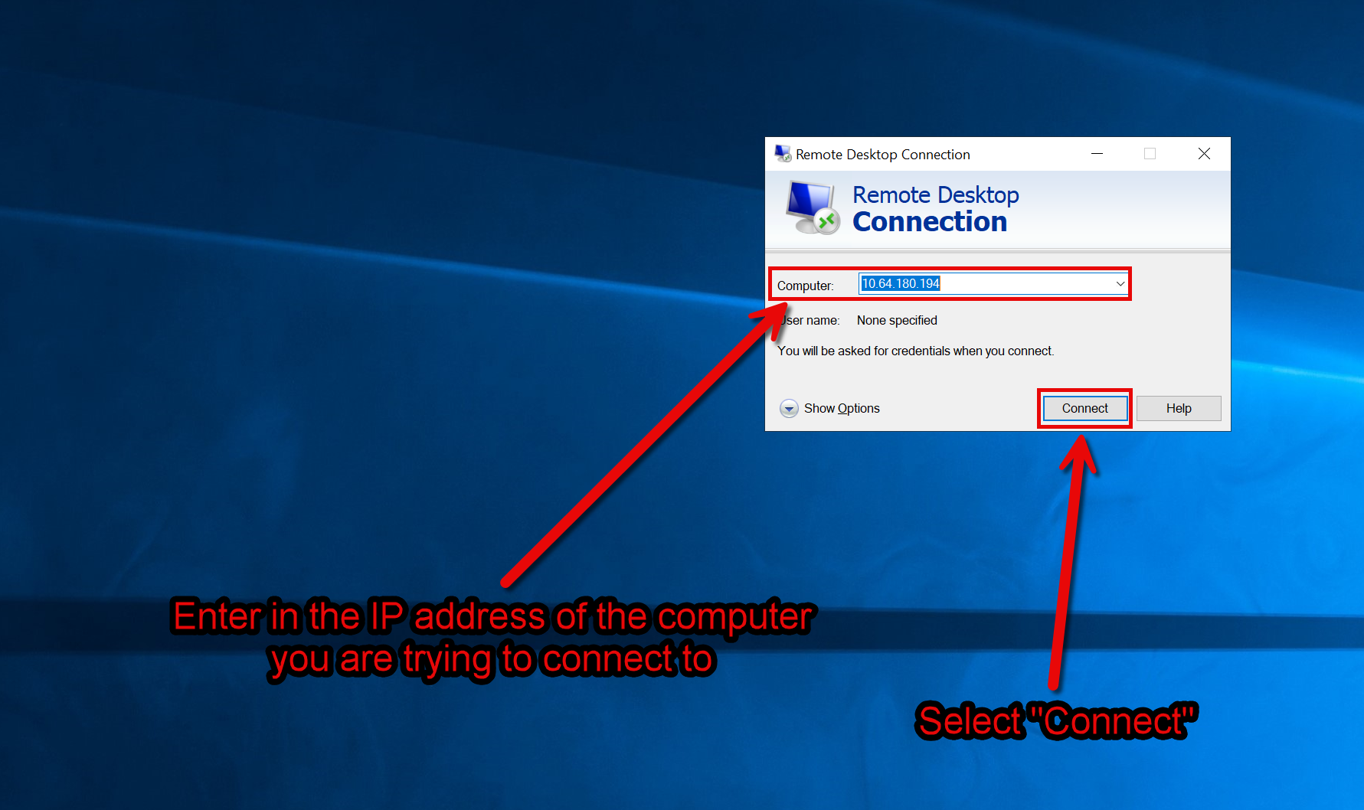
The Current List of station IP’s:
IG02422 | Saanich Peninsula | 10.64.180.194
IG02318 | Royal Jubilee | TBD
IG02319 | Victoria General | TBD
Once Logged in you will need to Log in as the Administrator account. Currently we are unable to log in under the standard user account; use the Password “MEPSINC.” to log into the Admin User account.

