Knowledge Article Template

🔹 Article Title:

Legacy showing “Kit & Tray Management System Error”
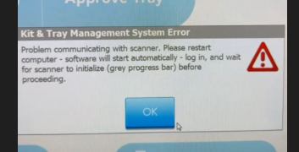

🔸 Applicable Device Information:
- Device Type: Pharmacy
- Software/Firmware Version: Legacy

🔹 Problem Description:
After logging in and attempting to scan anything, the system will populate this error and not allow you to scan anything.

🔸 Common Symptoms:
- User is unable to use the enclosure

🔹 Common Causes:
(List likely root causes based on previous incidents or manufacturer guidelines.)
- IG services is running in the background.

🔸 Common Resolutions / Troubleshooting Steps:
(Step-by-step instructions or resolutions. Include preventative actions if applicable.)
- Check physical connection – Ethernet should be connected to the adapter and enclosure should be directly connected to the back of the computer. Unplug everything and leave it for 30sec atleast. Then plug back in and allow to restart.
- Ensure that IG Services are not running- If you are receiving a WebAPI error in SEQ , this maybe a hint. Can be checked under services in settings.
- If IG Services are running – right click on IG services and then click stop. This will stop the services.
- To disable services – right click > properties > Startup Type : Disabled > okay
- Restart the computer – and see if this solved the issue.

🔹 Last Updated By:
- Name/Role: Amber Schauer, Clinical Support Specialist
- Date: 09/02/2025
- Version: 1.0

