Knowledge Article Template

🔹 Article Title: NON-RFID ITEMS (Supply Items) Quick Reference Cheat Sheet.

🔸 Applicable Device Information:
- Device Type: Mire Prep, Mire Care, Mire ENTERPRISE SYSTEM
- Software/Firmware Version (if applicable): any version

🔹 Problem Description:
Calls are made to internal support referencing supply items that may need to be added to the database for various tracking or formulary reasons. It can be vague to understand the clients’ needs without having a reference point of what supply items are or how they are labeled and stored.

🔸 Common Symptoms:
Client Calls to Support when leadership is not available to help add non-RFID items to the Enterprise Database.

🔹 Common Causes:
- NON-RFID Items do not populate in RXNorm.
- Clients will want to track expiration date of supply items

🔸 Common Resolutions / Troubleshooting Steps:
(Step-by-step instructions or resolutions. Include preventative actions if applicable.)
- Below is a list of common supply items.
  - Usually, clients will NOT TAG supplies and add them to non-RFID items for formulary build use.
- Non-RFID items may not have standard Product Codes to import from RXNorm.
- Customers may choose to tag and create “custom items” to track supply items, resulting in the need for a “Product Code”
- Compare non-RFID item with Caller – use this list to help compare supply items as needed to guide the client through using product code that is most relevant to their enterprise. (may require pharmacy leadership input. Pharmacy leader may alternate product code with REF (reference number) on the product if a 2D barcode is not available to scan).

- See Examples of Common Supply Items in the following pages:

a) 0.9% Sodium Chloride Injection (Flush) 10mL (NS=Normal Saline = 0.9% Sodium Chloride)
Item Image: 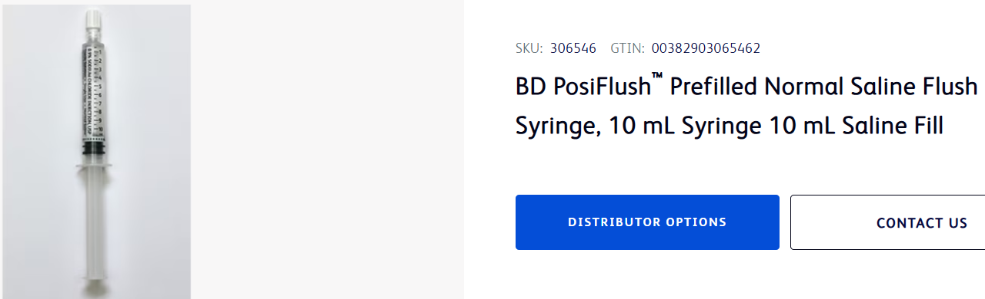
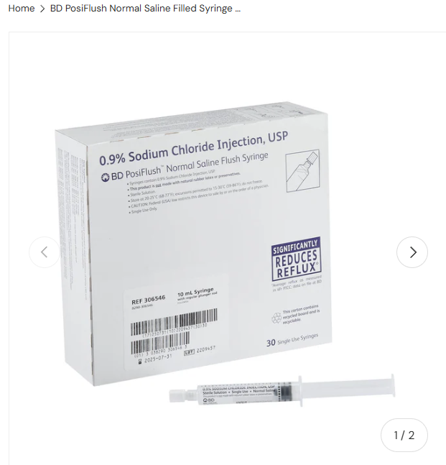
Flush box of 25
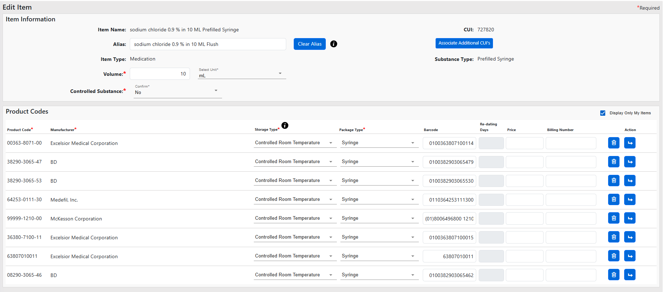
Resource Link: https://www.bd.com/en-us/products-and-solutions/products/product-page.306546

b) 0.9% Sodium Chloride Injection (Flush) 3mL (NS=Normal Saline = 0.9% Sodium Chloride)
Item Image: 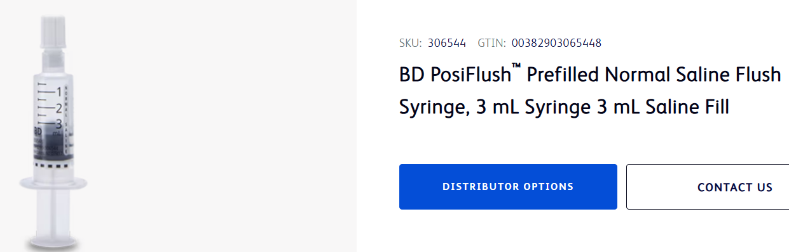
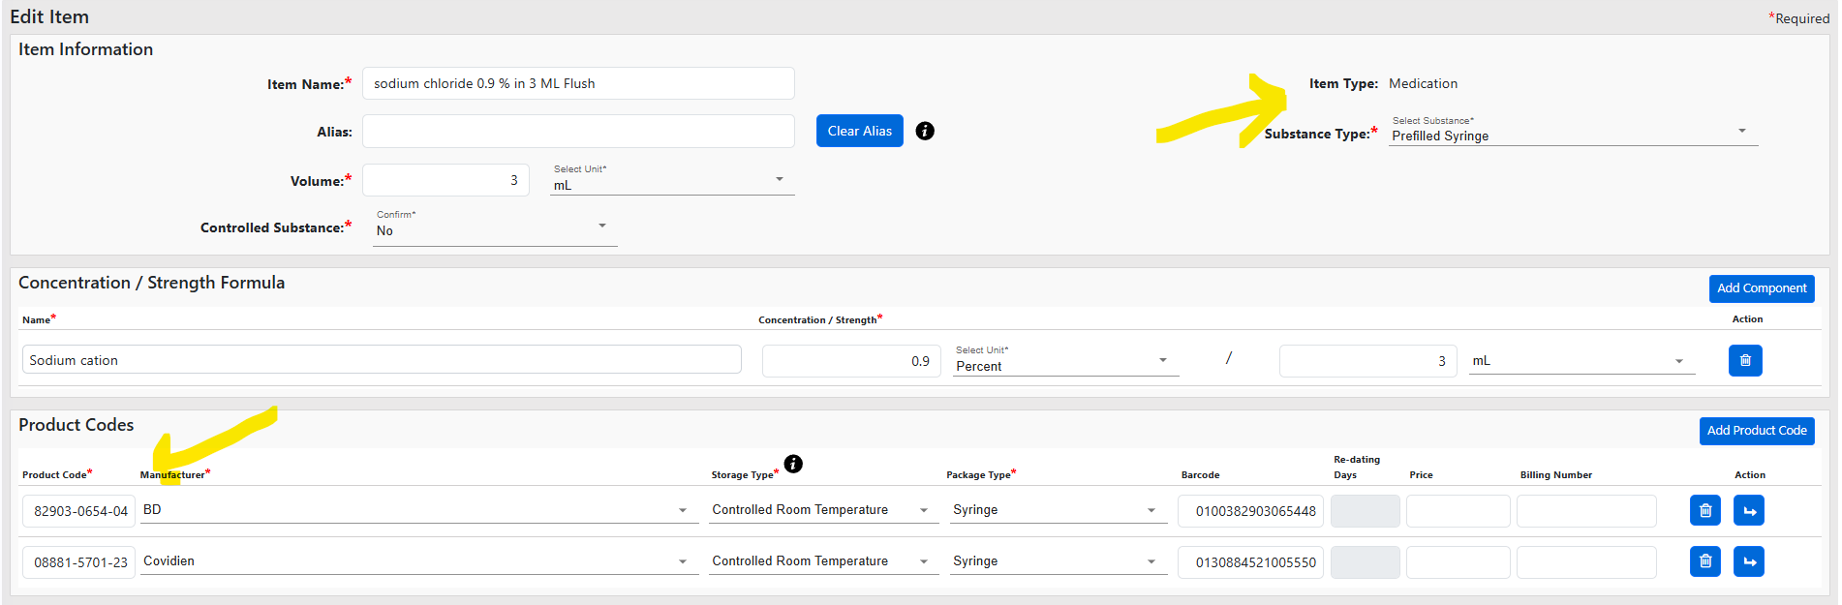
Resource Link: https://www.bd.com/en-us/products-and-solutions/products/product-page.306544

c) Syringe – Luer Lock 10ml
Item Image: 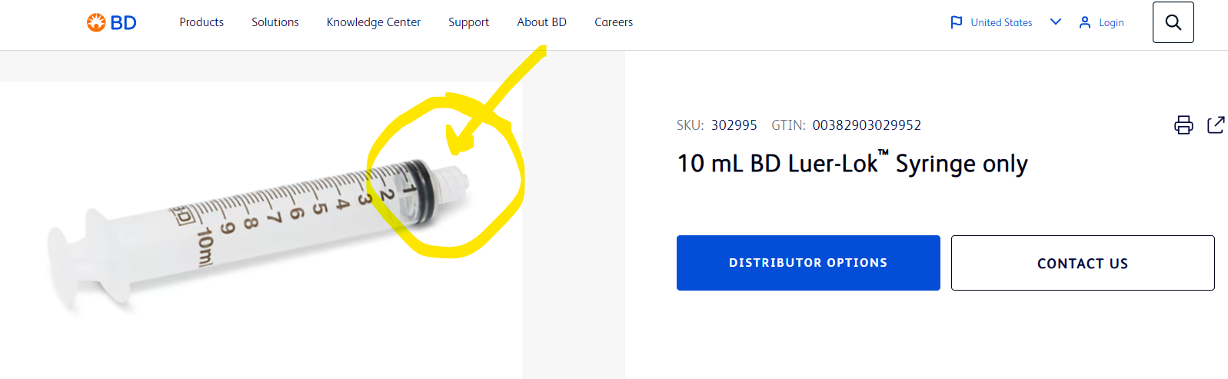
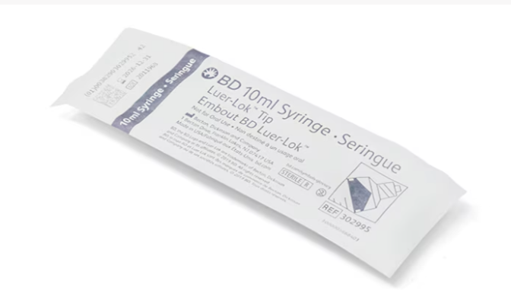

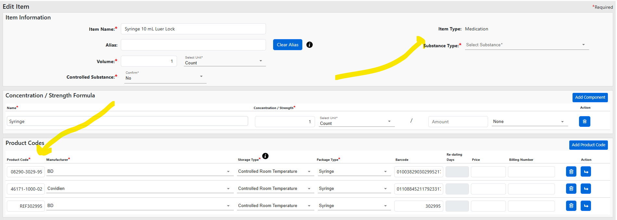
Resource Link: https://www.bd.com/en-us/products-and-solutions/products/product-page.302995

d) Syringe 1mL Tuberculin Safety
Item Image: 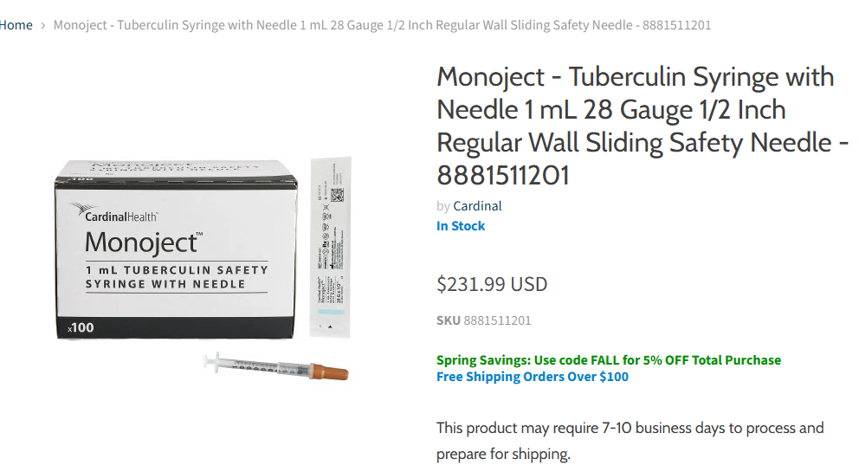
Resource Link: https://serfinitymedical.com/products/kcm23-monoject-tuberculin-syringe-with-needle-1-ml-28-gauge-12-inch-regular-wall-sliding-safety-needle-8881511201-295803?variant=39943075790923&gad_source=1&gad_campaignid=19692553909&gbraid=0AAAAAC5zGAW56FwDWbUIywLbAFqGE8R09&gclid=EAIaIQobChMImZ_--eaDkAMVLEn_AR3JjxXyEAQYAiABEgK1EvD_BwE or https://www.cardinalhealth.com/en/product-solutions/medical/patient-care/sharps-safety/medication-delivery/safety-needles-and-syringes/monoject-insulin-and-tuberculin-safety-syringes.html

e) 3mL Luer Lock Syringe
Item Image:
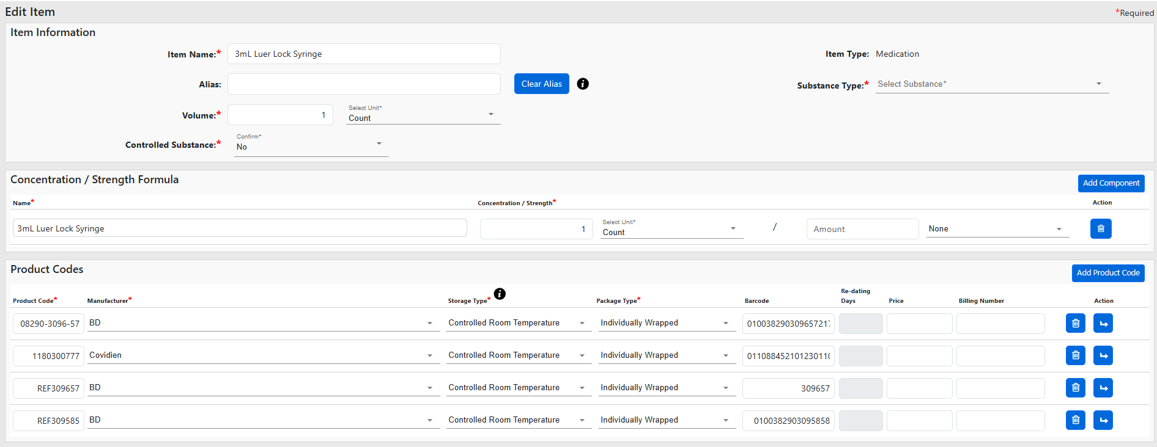
Resource Link: https://www.dotmed.com/listing/disposables-general/bd/309702/vacutainer-syringe-luer-lok-tip-3ml-300-casex/2764519?utm_source=base&utm_medium=search&utm_campaign=Base

f) Alcohol Swabs/Pads
Item Image: 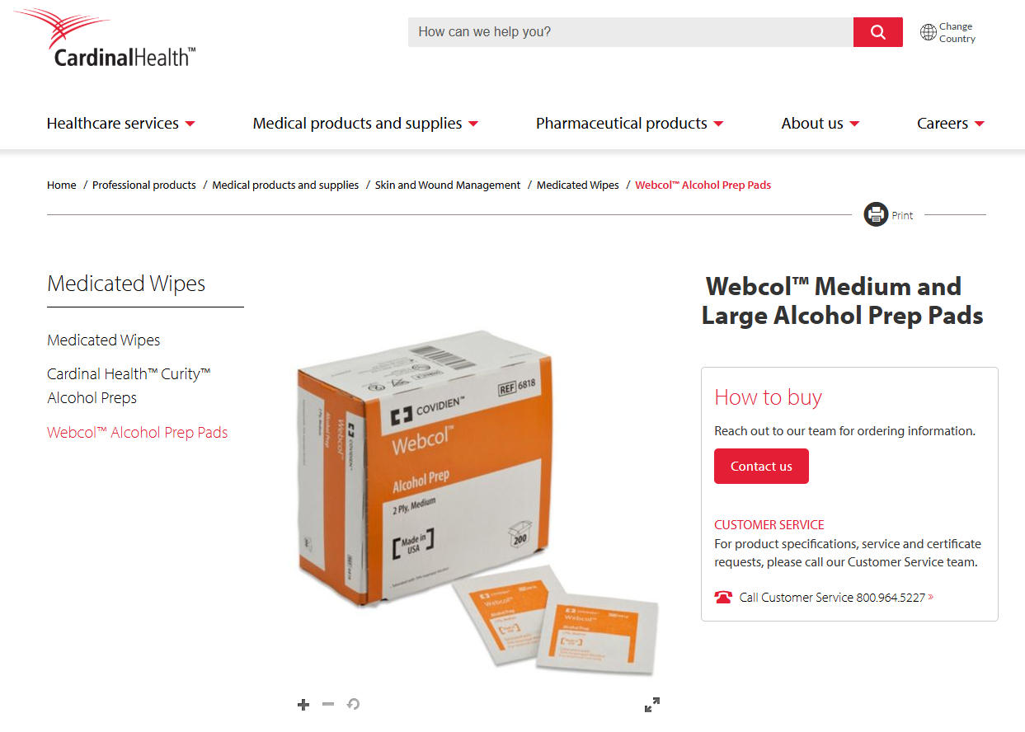
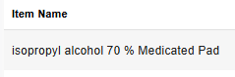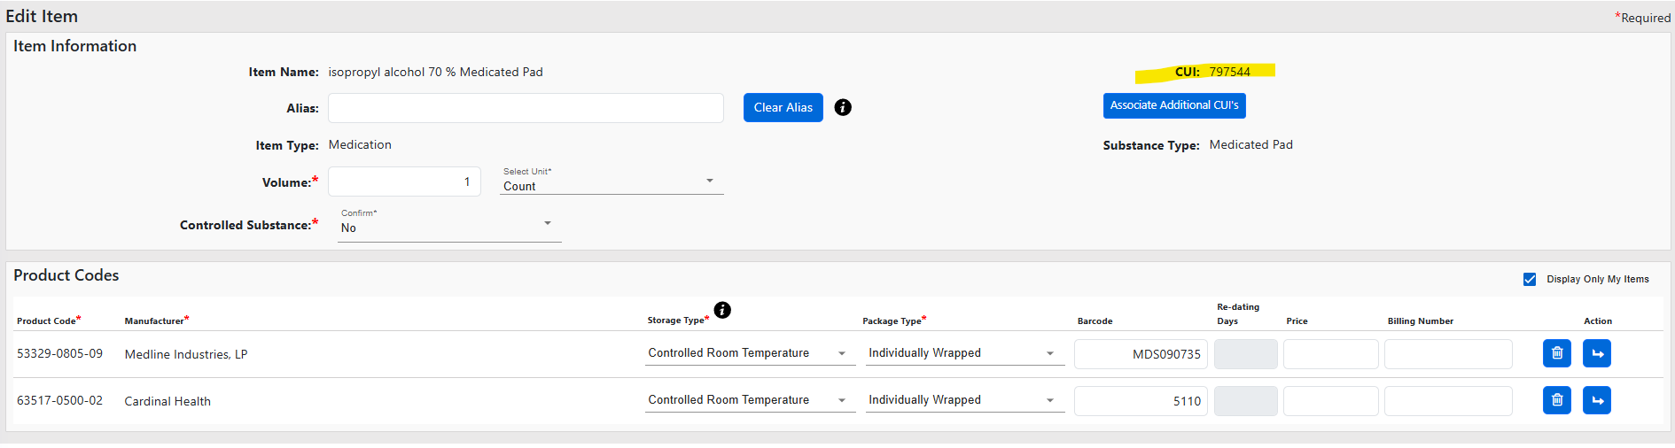
Resource Link: https://www.cardinalhealth.com/en/product-solutions/medical/skin-and-wound-management/medicated-wipes/webcol-alcohol-preps.html

g) 21G Needles
Item Image:

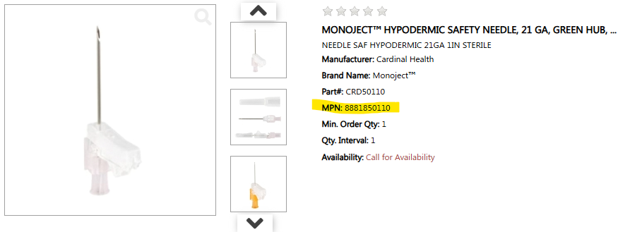
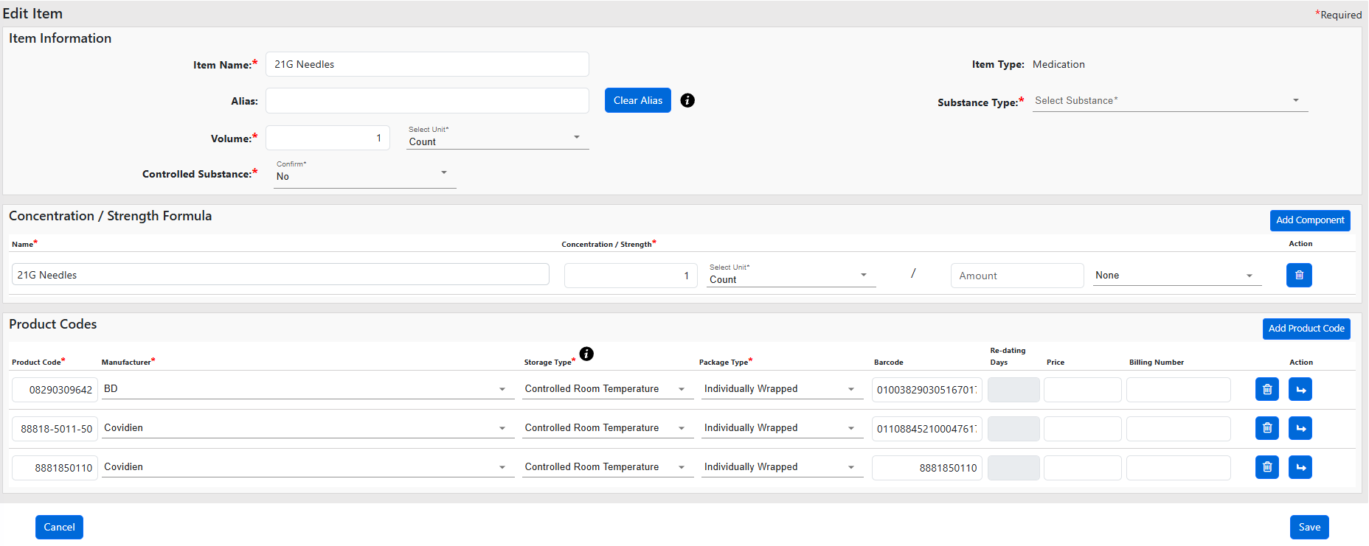
Resource Link: https://mms.mckesson.com/product/128989/BD-309642 or https://www.unitedmedsupply.com/monoject-8881850110-crd50110

h) bandages (individually wrapped)
Item Image:
Resource Link:

i) Gauze-Sterile (individually wrapped)
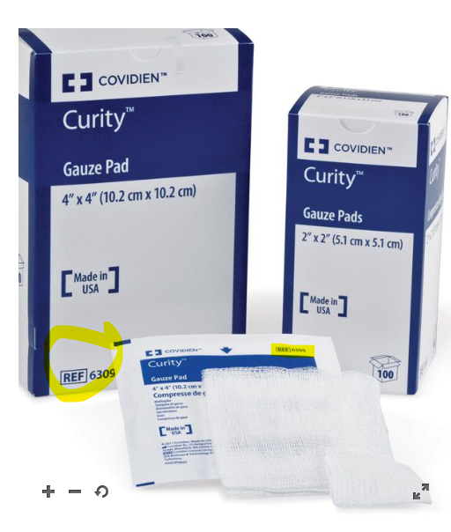
https://www.cardinalhealth.com/en/product-solutions/medical/skin-and-wound-management/traditional-wound-care/woven-dressings/curity-sterile-gauze-pads.html

g) Tray Lock Tags
Item Image: 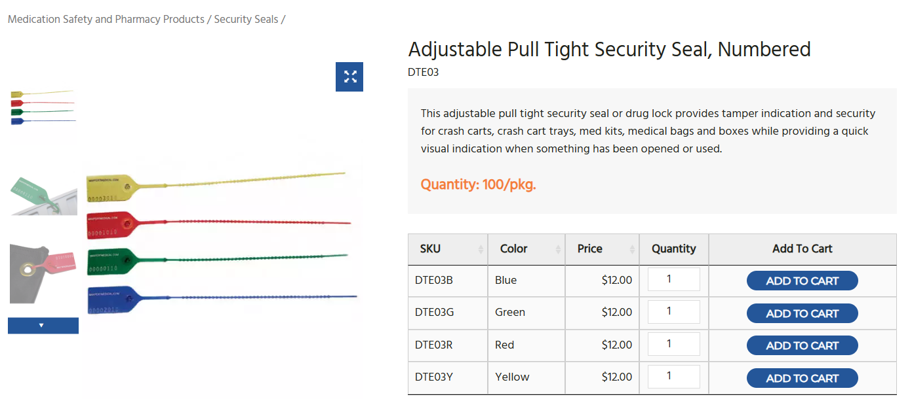
Resource Link: https://maxpertmedical.com/security-seals/adjustable-pull-tight-security-seal-numbered/
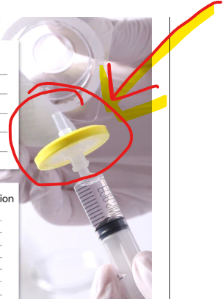
h) Filter Micron 0.22 Image:
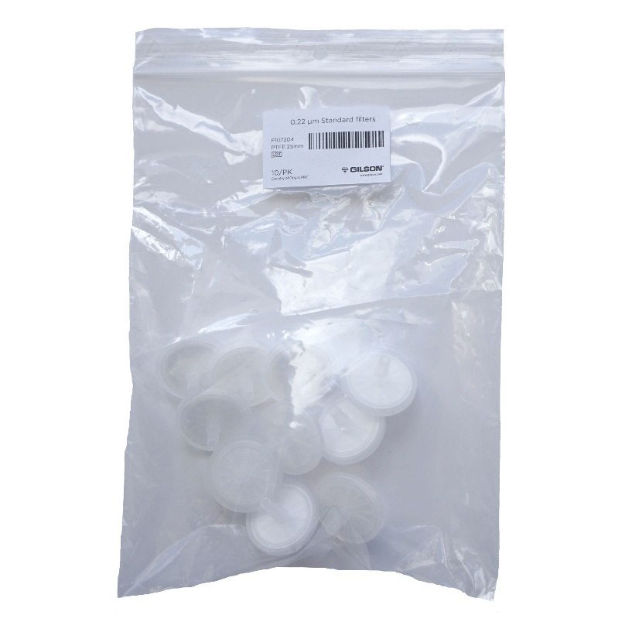

Links: https://www.gilson.com/default/system-filter-for-macroman.html?srsltid=AfmBOoo4P1uBPgPIflVxBDnN50SPOMjJ0-geahZHgE3Wxq2yLiUvmUlNQ60
https://shop.cobetter.com/products/sterile-0-22-um-pes-syringe-filters-for-sterile-filtration?srsltid=AfmBOoq1amDlWy4JvCqFgboT2FsXDhI-FqaAn_uhkOUr1Vu6ZuouNrpt

g) Blunt Filter Needle (in kits that have glass ampules)
Image: 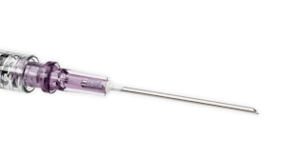
BD® Blunt Filter Needles
- Are specifically designed to help reduce the risk of needlestick injuries during medication preparation*
- Features a filter with a 5 micron membrane that is designed to prevent large particles from being drawn into the syringe when preparing medications from ampoules
- Align to the 2024 INS Standards of Practice which recommend using a blunt filter needle when preparing medications from glass ampoules.²
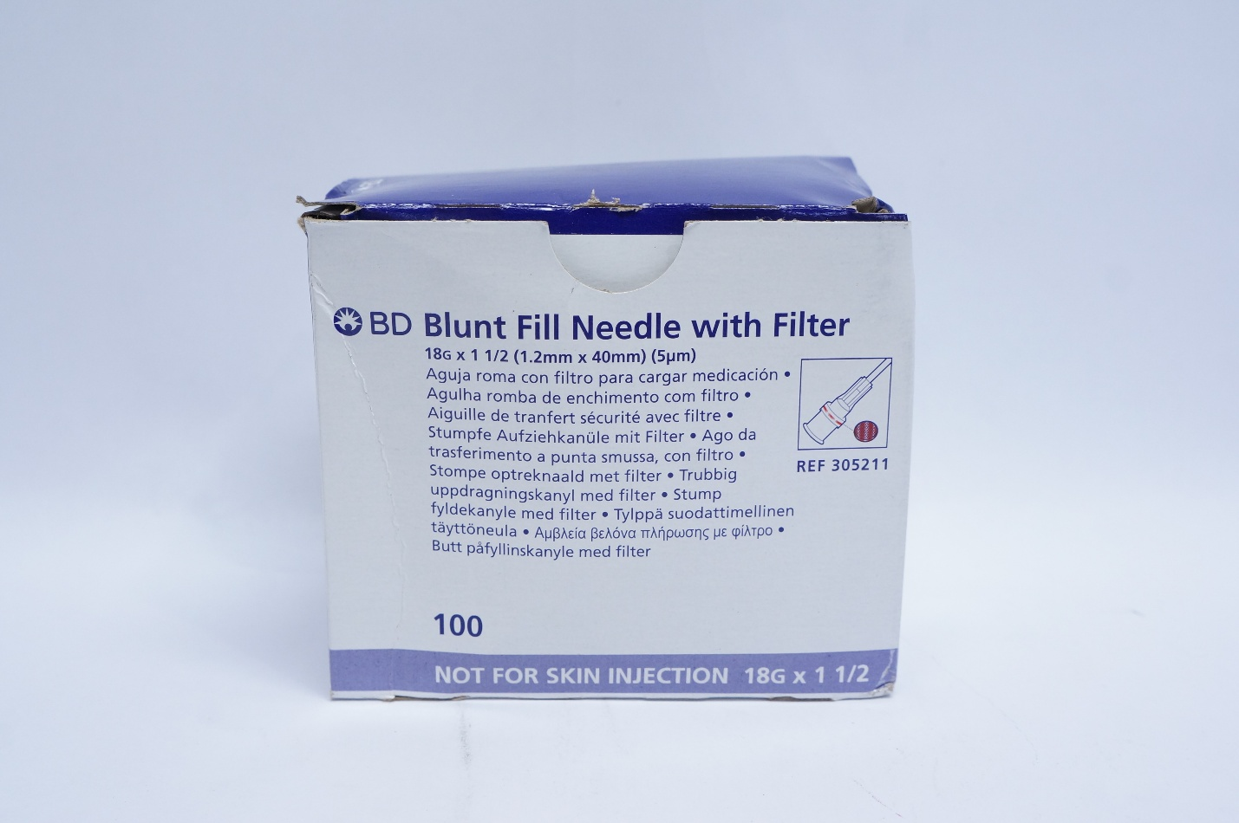
Link: https://imedsales.com/bd-305211-blunt-fill-ndle-with-filter-18g-x-1-1-2inch-box-of-100-2?srsltid=AfmBOorMZzV3F6aOrgi1M0hthjU_XukBDLIBkMKgdNmvf-j8qhaYhEVQKyA

🔹 Escalation Criteria:
(When to escalate the issue to Development or Implementation team.)
- Issue persists after all troubleshooting steps have been attempted.
- Recurrent Tag(s) showing up (needs filtered out).
- Customer workflow is at a standstill.

🔸 Related Documentation or References:
(Links or titles of user manuals, service bulletins, or SOPs.)
- Pharmacy Leadership
- Troubleshooting Guide: Pharmacy Hardware

🔹 Last Updated By:
- Name/Role: Sara Thompson / Implementation Specialist
- Date: 10/03/2025
- Version: 1.0

