🔹 Badge Reader Issues

🔸 Applicable Device Information:
- Device Type: Mira Prep, Care and Supply
- Software/Firmware Version (if applicable): Legacy, Enterprise

🔹 Problem Description:
User is unable to log into the unit with their badge

🔸 Common Symptoms:
- Badge Reader non-functional
- “Badge Password Incorrect” error when trying to log in

🔹 Common Causes:
(List likely root causes based on previous incidents or manufacturer guidelines.)
- Damaged badge reader
- Incorrect configuration on reader
- Improper badge placement when scanning
- User not assigned to a facility
- User has never logged into the system
- Facility has switched to new SEOS Smart Badges

🔸 Common Resolutions / Troubleshooting Steps:
(Step-by-step instructions or resolutions. Include preventative actions if applicable.)
- Inspect Badge Reader for damage (Pharmacy Only)
- Unplug and Re-plug in the badge reader (Pharmacy Only)
- Verify that the badge reader is beeping/lighting up when scanning a badge
- Have the user ensure their badge is parallel with the reader not perpendicular.
- Use Notepad++ to verify that the badge reader is populating a string when scanning the badge. Using Notepad++ is also how you can tell if the client has a new SEOS Smart Badge. If they do, you’ll see the badge # string change with each scan. If they have these new types of badges, they will require new smart badge readers which can be ordered & shipped to them.
- If a string is populating check for Delimiters showing before and after the string
e.g. [12345] vs 12345
Legacy Requires the “[ ]” delimiters, Enterprise requires NO delimiters
- If the Delimiters are not present when they should be (Legacy) or vice versa (Enterprise) you will need to adjust the badge reader configuration to fix this.
For the example I will be adding the delimiters, the process is the same for removing them, just select NONE instead of INSERT if you need to remove the delimiters.
  - Open the badge reader configuration tool PCProx or RFIdeas
NOTE: the process is essentially the same, the only real difference is in the user interface of the configuration utility.
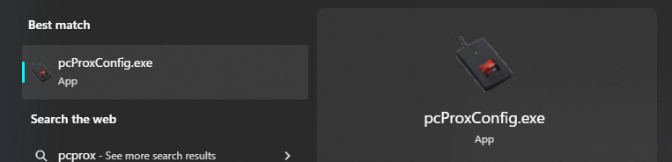
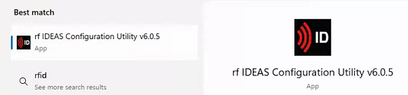
Ensure the Firmware version is correct and that the correct card type is selected (Image from RFIdeas):
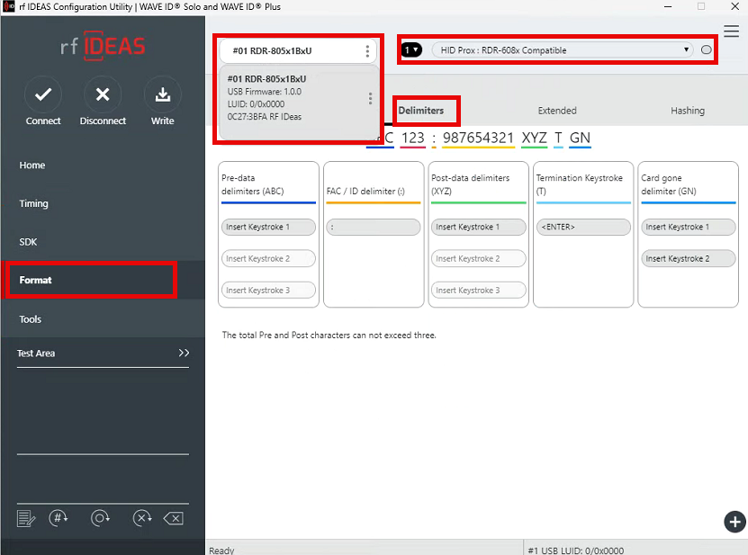
  - Navigate to the Format and Delimiters tabs (Image from PCProx)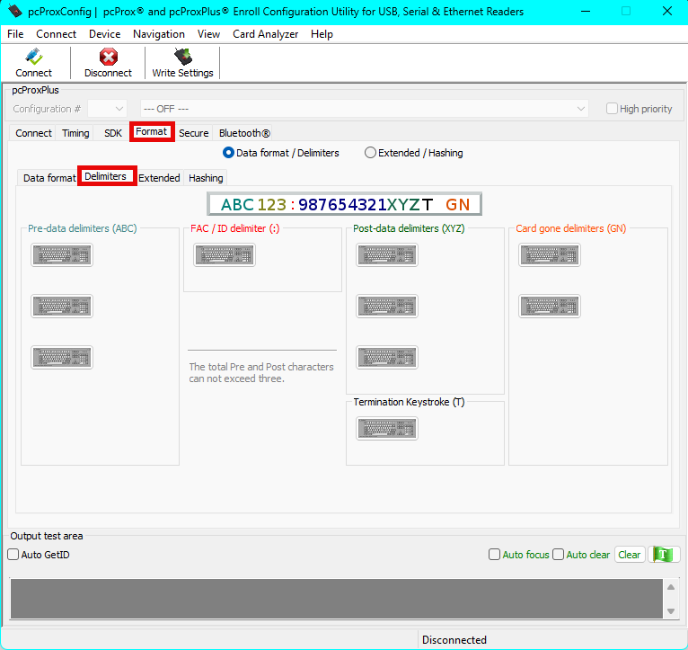
  - Select the first keyboard image under Pre-data delimiters (ABC)
  - Select “[“ (open bracket)
  - Select Insert
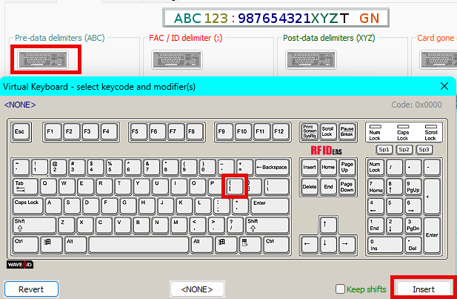
  - Repeat for the keyboard image under Post-Data Delimiters (XYZ) ensuring a “]” closed bracket is selected if done correctly it should look like the below image:
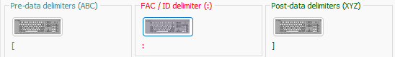
  - Select “Write Settings” at the top of the configuration tool.
this may take a shot while but make sure to repeat the above processes for ALL configuration numbers if multiple configuration choices are present in the dropdown
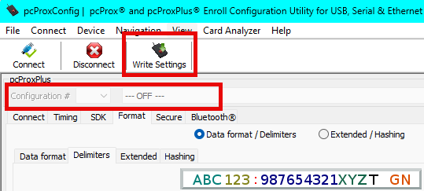
  - After completing the addition or removal of delimiters and writing the settings to the reader, it should now be configured correctly.
  - Test and verify with the user that a sting populates in Notepad++ and ensure the delimiters are registering or not present depending on your requirement (Legacy vs Enterprise)
  - Test and verify that the user can log in after scanning their badge.

🔹 Escalation Criteria:
(When to escalate the issue to Development or Implementation team.)
- Issue persists after all troubleshooting steps have been attempted.
- Customer workflow is at a standstill.

🔸 Related Documentation or References:
(Links or titles of user manuals, service bulletins, or SOPs.)
- Troubleshooting Guide: Pharmacy Hardware

🔹 Last Updated By:
- Name/Role: Chris Schramm
- Date: 9.25.25
- Version: 1

